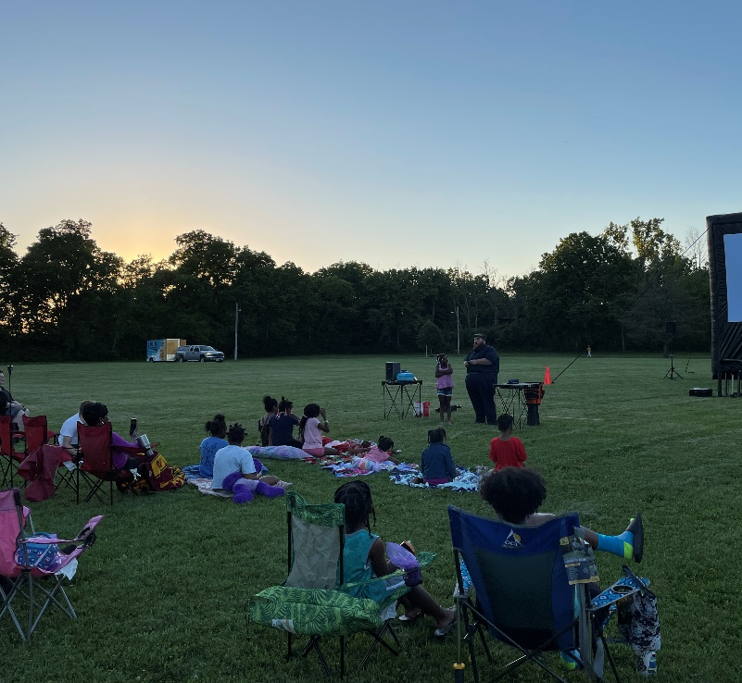
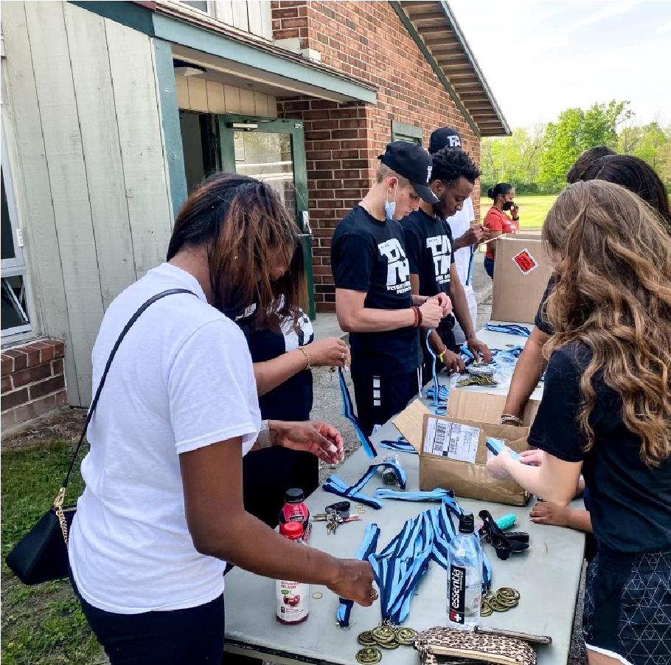
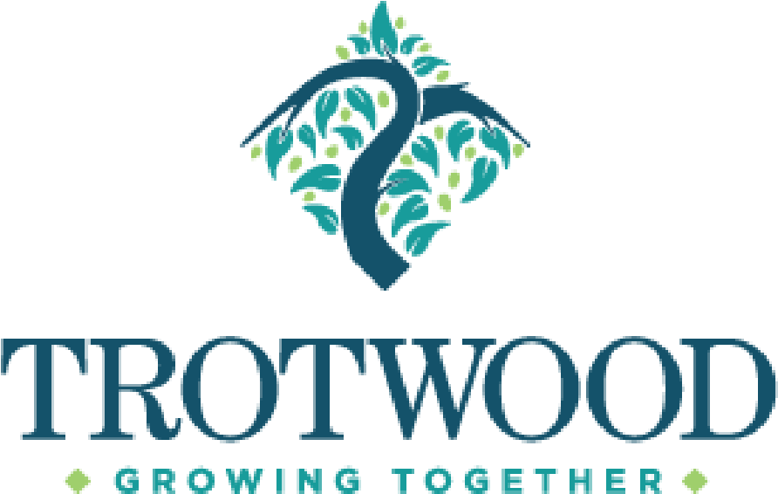
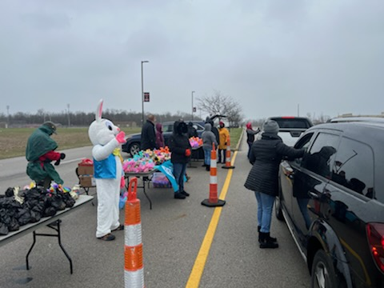
Sponsorships
C
o
m
m
u
n
i
t
y
TROTWOOD
PARKS AND
RECREATION
937-854-7228
2
022
. Please review sponsorships
1
opportunities on the following pages and
complete the
Sponsorship Letter of Intent

2
. Submit Letter of Intent to
:
Email: chwheeler@trotwood.org
or
City of Trotwood Parks and Recreation
Attn: Sponsorship
3035
Olive Road
Trotwood, Oh 45426

For questions, please reach out to Charles
Wheeler III at 937-854-7228 or
chwheeler@trotwood.org
2022
Special Event
Sponsorship Opportunities
Interested in Sponsoring an
Upcoming Event?
When
Friday, October 28, 2022
Time: 6pm-8pm
Where
Madison Park

301 S Broadway Ave, Trotwood, OH 45426

What
We are expecting this event to be Spooktacular! With the help of our
community supporters, we are capable of promoting local
businesses while providing a safe family-friendly event. Please
review the following information and learn how you can participate
on Friday, October 28th for this event.
Who
Children must be present in vehicle. Ages 13 and under, please.

Sponsorship Deadline
Monday, October 10, 2022 for logo inclusion on print materials
Drive- Thru Trick-or- Treat

Drive- Thru Trick-or- Treat Sponsorship Levels
Monster Sponsor - minimum $300

Recognition as the Title sponsor
- Logo/Name placement in all marketing communications.
- Logo placement on all print materials.
- Logo placement on event website with link to your website.
- Recognition of sponsorship in all social media blasts.
- City will provide a 10’ x 10’ canopy in premier location with a table and two chairs for you to promote your organization.
- Logo displayed at event (banner provided by sponsor).
- Verbal recognition of sponsorship.
- Invitation to include promotional flyers of your business in treat bags (approx.500 bags).

Event Sponsor - $150
- Logo placement on all print materials.
- Logo/Name placement in all electronic communications, event notifications, and newsletters.
- Logo placement on event website with link to your website.
- Recognition of sponsorship in all social media blasts.
- Logo displayed at event (banner provided by sponsor).
- Verbal recognition of sponsorship.

Supporting Sponsor - $75
- Recognition of sponsorship on social media.
- Logo displayed at event (banner provided by sponsor).
- Verbal recognition of sponsorship.

Vendor
• Set up personal booth and pass out goodies to the youth

2022 Sponsorship Letter of Intent
Sponsor Information
Company/Organization Name
Contact Person's Name
Address
City | State | Zip
Phone No. Cell Phone Fax

Email Website
Event Sponsorship Opportunities (Please fill circle)
Drive-Thru Trick-or-Treat
Monster Sponsor Event Sponsor
Supporting Sponsor Vendor

2022 Sponsorship Letter of Intent (Cont'd)

Payment
Amount Payable to City of Trotwood:
Payment included

Submission
Please submit this completed form with payment to:
Mail to:
City of Trotwood, Parks and Recreation
Attn: Charles Wheeler III
3035 Olive Rd, Trotwood, OH 45426

Contact/Questions
For questions about Sponsorship opportunities and to discuss availability, please contact Charles Wheeler III at chwheeler@trotwood.org or 937-854-7228. Interested in a sponsorship opportunity not listed or do you have a unique idea to add to one of our events? If so, contact Charles Wheeler III to discuss your idea.

We look forward to working with you and your organization to create community through people, parks, and programs!

