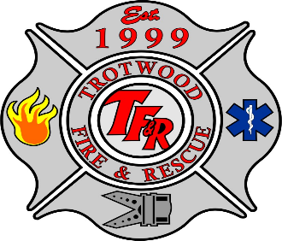
Thunderstorms and Lightning

What is a Thunderstorm?
Thunderstorms are generated by temperature imbalances in the atmosphere. Warming of the air near the earth's surface and/or cooling of the air above the earth’s surface puts warmer, lighter air layers below colder, denser layers. The result is an unstable air mass that produces a thunderstorm.

What is Lightning?
Lightning is a powerful natural electrostatic discharge produced during a thunderstorm.
Lightning is a serious hazard during thunderstorms and tornadoes. More people die from Lightning strikes than any other storm related incidents.

Precautions if you are threatened by lightning
Take these special precautions if you are threatened by lighting:
- When a thunderstorm threatens, get inside a home or large building or inside an all-metal vehicle, not a convertible.
INSIDE A HOME
- Avoid using the telephone, except for emergencies.
- Avoid places which may hold water such as sinks, tubs and showers.
OUTSIDE
If you have no time to reach a safe building or an automobile, follow these rules:
- Do not stand underneath a natural lightning rod such as a tall, isolated tree in an open area.
- Avoid projecting above the surrounding landscape, as you would do if you were standing on a hilltop, in an open field, on the beach or fishing from a small boat.
- Get out of and away from open water.
- Get away from tractors and other metal farm equipment.
- Get off of and away from motorcycles, scooters, golf carts and bicycles, and put down golf clubs.
- Stay away from wire fences, clothes lines, metal pipes, rails, and other metallic paths which could carry lightning to you from some distance away.
- Avoid standing in small isolated sheds or other small structures in open areas.
- In a forest, seek shelter in a low area under a thick growth of small trees.
- In open areas, go to a low place such as a ravine or valley. Be alert for flash floods.
- If you are isolated in a level field, and you feel your hair stand on end, drop to your knees and bend forward putting your hands on your knees. Do not lie flat on the ground.

The National Weather Service is responsible for issuing severe weather watches, warnings and advisories to alert the public.
For more information, please visit: www.nws.noaa.gov/severeweather/index.shtml and www.weathersafety.ohio.gov

