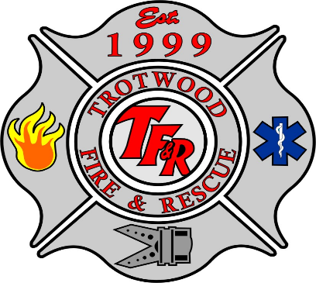
Floods

What is a Flood?
Floods are the most common and widespread of all natural disasters. Most communities in the United States can experience some kind of flooding after spring rains, heavy thunderstorms, or winter snow thaws. Floods can be slow, or fast rising but generally develop over a period of days. Flash floods usually result from intense storms dropping large amounts of rain within a brief period. Flash floods occur with little or no warning and can reach full peak in only a few minutes.
The National Weather Service is responsible for issuing severe weather watches, warnings and advisories to alert the public.
For more information, please visit: www.nws.noaa.gov/severeweather/index.shtml and www.weathersafety.ohio.gov

