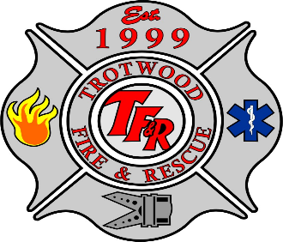
During the Storm

Safety Tips & Guidelines
- If you lose power, do not put a generator inside or near water.
- When using a barbeque grill, keep it outdoors to avoid carbon monoxide poisoning or a fire.
- If you must drive – when traffic lights are out, treat the intersection as a four-way stop.

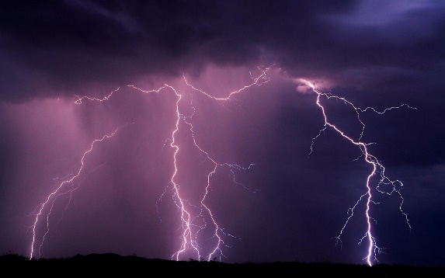
Precautions - During the Storm if Sheltering at Home
- Safe Room - Have a safe, interior room with no windows ready with all your supplies (food, lights, radio, camera, purse, insurance policy copy, medications, glasses, blanket, pillows, mattress). Stay There! Remain indoors during the Tornado. Blowing debris can injure or kill. Travel is extremely dangerous.
- Animals should be placed in their carriers.
- Windows and Doors - Stay away from all windows and doors. DO NOT open a window on the opposite side of the winds as we have been advised in the past.
- Candles - DO NOT use; they can blow over.
- Power - Turn off all appliances at the fuse box (circuit breaker) or remove fuses when the power begins to be intermittent or when flooding begins. Leave one breaker on that operates a light.
- Lightning - If you are outside and your hair stands on end or your skin tingles, lightning may be about to strike you. Drop to the ground and bend forward with hands on knees.
- Radio/TV- Tune to a local radio or television station.
The National Weather Service is responsible for issuing severe weather watches, warnings and advisories to alert the public.
For more information, please visit: www.nws.noaa.gov/severeweather/index.shtml and www.weathersafety.ohio.gov

